PROJECTS
Title | Researcher | Department | Funding Agency | Project Duration | Relevant SDGs
Mobilizing Advanced Partnerships for Digital Innovation and Transformation | Tolga Ayav | Computer Engineering | European Commission | 2024-2026 | 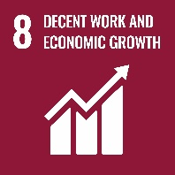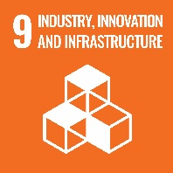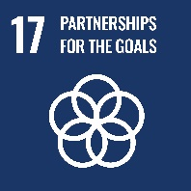
Biomedical Technologies and Innovation (BIOTIN) COFUND doctoral Programme | Volga Bulmuş | Bioengineering | European Commission | 2023-2028 | 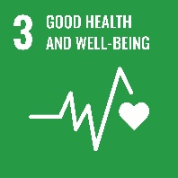
Sustainable Water Management (Water4All) Doctoral Programme | Orhan Gündüz | Environmental Engineering | European Commission | 2024-2029 | 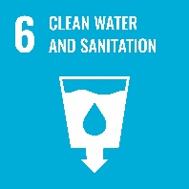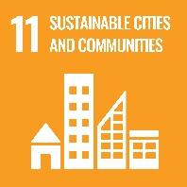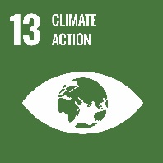
Climate Adaptation and Resilience Demonstrated In the MEDiterranean region (CARDIMED) | Koray Velibeyoğlu | Urban and Regional Planning | European Commission | 2023-2028
Eyes Hearts Hands Urban Revolution | İpek Akpınar | Architecture | European Commission | 2022-2025 | 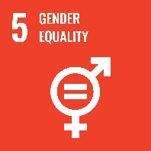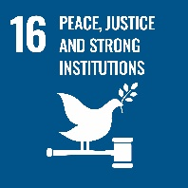
Piloting Open and Responsible Activities and Trainings Towards the Enhancement of Researchers Networks - PATTERN | Gültekin Gürdal | Library and Documentation Directorate | European Commission | 2023-2026
Secured and intelligent massive machine-to-machine communications for 6G - SCION | Berna Özbek | Electronics and Communication Engineering | European Commission | 2023-2027

